Project Documentation: 8-bit Structural ALU

1. Project Overview and Objectives
The main objective of this project was to design and simulate an 8-bit Arithmetic Logic Unit (ALU) using the Verilog hardware description language. The primary requirement, which was also the biggest challenge, was to implement the design at a strictly structural level. This meant minimizing behavioral code and building the circuit using basic components (flip-flops, logic gates, multiplexers).
Our ALU supports 4 basic operations, selected by a 2-bit opcode (alu_op):
- 00 - Addition
- 01 - Subtraction
- 10 - Multiplication - implemented using the Booth Radix-2 algorithm.
- 11 - Division - implemented using the Restoring Division algorithm.
We chose the Booth Radix-2 algorithm because it natively handles signed numbers in 2's complement, eliminating the need for a separate module to convert signs before and after the multiplication. We chose the Restoring Division algorithm because it is highly efficient to implement structurally. The 'restore' step was achieved simply by disabling the register's load signal when a subtraction was negative, avoiding the need for additional adder circuits and keeping the hardware minimal.
For code development, we utilized Visual Studio Code (VS Code) as our primary Integrated Development Environment (IDE). The HDL compilation and simulation were performed using Icarus Verilog, which generated the necessary .vcd (Value Change Dump) files. Finally, we used GTKWave to visualize and analyze the simulation waveforms, allowing us to verify the timing and correctness of our structural implementation.

2. Architecture Diagrams and Explanations
The project architecture is divided into clear logical blocks, separated into individual files, following a "Top-Down" hierarchy. The main module, alu_top, does not perform any direct calculations; it only connects the modules together using wires.
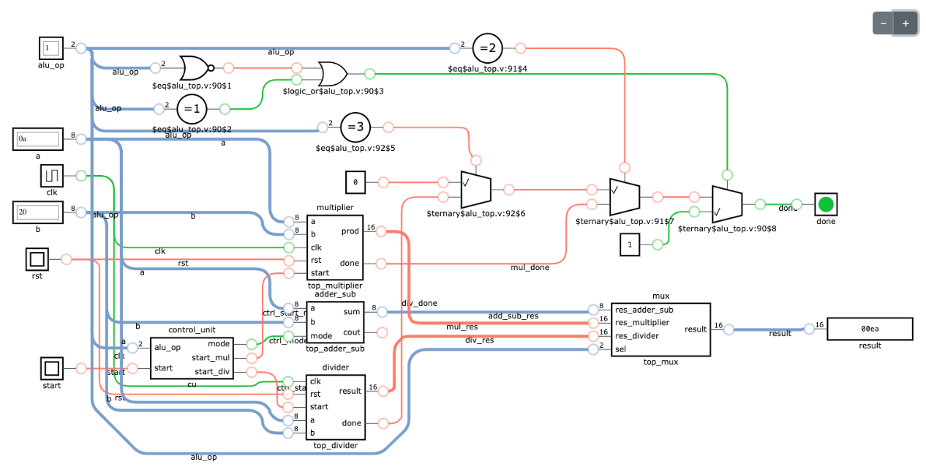
Architecture breakdown:
- Control Unit (cu): Acts as a dispatcher. It receives the opcode and the global start signal and translates them into individual control signals for the rest of the modules (ctrl_mode for the operation sign, ctrl_start_mul, ctrl_start_div). This ensures that modules not used in a specific cycle remain inactive.
- Arithmetic (Data Path): The a and b inputs are fed in parallel into the 3 calculation modules:
  - top_adder_sub: A purely combinational module. It chooses between computing A + B or A + (~B) + 1 based on the mode signal.
  - top_multiplier and top_divider: These are sequential modules that contain their own internal Finite State Machines (FSMs) and shift registers built from individual DFF cells.
- Multiplexer (top_mux): All results are routed into the MUX. It selects the final output (result) based on the opcode. The mux was built exclusively from logic gates (AND, OR, NOT) using boolean masks, perfectly adhering to the structural design constraints.
- Done Signal: This is generated combinationally for Add/Sub (since they are ready in the same clock cycle) and taken directly from the FSMs for the sequential operations (Mul/Div).

3. HDL Code Listings
The code was organized with a focus on reusability and gate-level design. For example, instead of using the >> operator or always blocks to build the registers, we created a separate dff (D Flip-Flop) module. Then, we used generate blocks to instantiate 8 such flip-flops, manually wiring them to create a right-shift register (register_8 for Booth) and a left-shift register (register_8_left for Restoring Division).
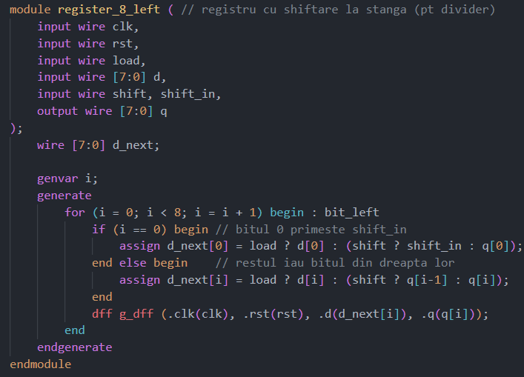
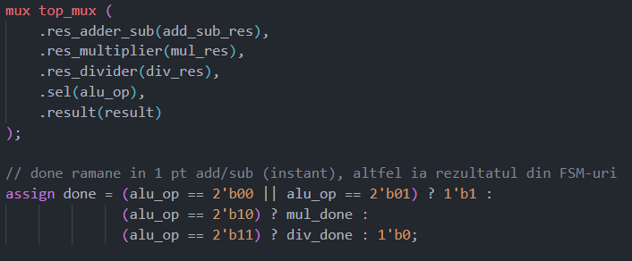
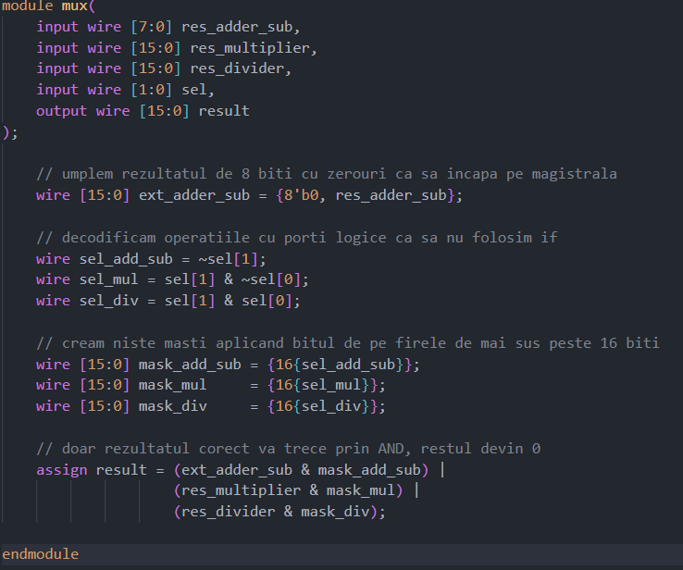
Each complex mathematical module (multiplier and divider) internally instantiates its own adder_sub module, thus maintaining a clean separation of responsibilities.
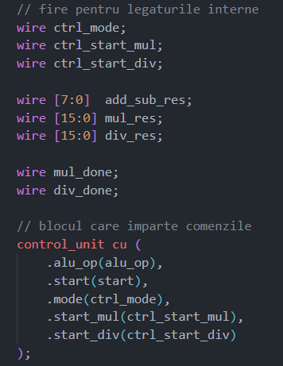
4. Testbench Descriptions and Simulation Waveforms
To validate the functionality, we wrote a global testbench (tb_alu_top.v) that instantiates the ALU and runs through a sequential scenario testing all 4 operations. The testbench uses a proper handshake for the multiplication and division operations: it sends a start pulse, then waits for the done signal to rise and fall (@(posedge done); @(negedge done);) before reading and displaying the result.
- Test 1 & 2 (ADD, SUB): The operations responded in a single clock cycle. The subtraction test with a negative result (10 - 30) correctly output 236 (the representation of -20 in 8-bit 2's complement).
- Test 3 (MUL): We performed a positive multiplication (12 * 5 = 60), followed by a multiplication with negative numbers to demonstrate the efficiency of the Booth algorithm (-2 * 15 = -30, displayed as FFE2 on 16 bits).
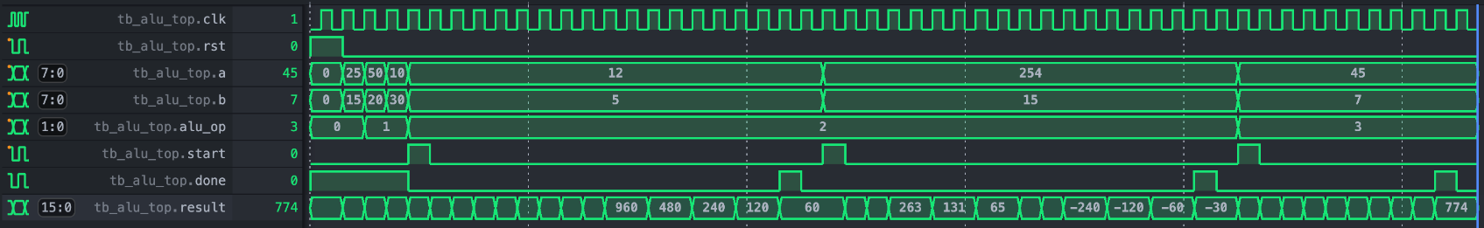
- Test 4 (DIV): The division 45 / 7 generated the expected result after the FSM finished: Quotient = 6 and Remainder = 3. By design, the remainder is stored in the upper bits result[15:8], and the quotient in the lower bits result[7:0].

5. Discussion of Results, Issues Encountered and Resolutions
Throughout the development of the project, we encountered several architectural issues that we had to resolve in order to maintain a strict structural and functional design:
- Issue: Incorrect shift direction in the divider.
  - Description: Initially, we used the same shift register (register_8) for both multiplication and division. The division results were wrong because Restoring Division requires a left shift, while Booth requires a right shift.
  - Resolution: We separated the hardware by creating a dedicated register_8_left module, altering the bit routing logic between the D inputs and Q outputs of the internal flip-flops.
- Issue: Race condition between the Testbench and the FSMs.
  - Description: The testbench was getting stuck after the first multiplication because it issued the start signal for the next operation before the FSM could transition from the DONE state back to IDLE.
  - Resolution: We implemented a safe synchronization in the test script by adding a wait for @(negedge done); after checking the positive edge, giving the state machine one clock cycle to clear itself.
- Issue: Multiplexer violating structural requirements.
  - Description: A classic multiplexer implementation using if-else statements or ternary operators (? :) is considered behavioral.
  - Resolution: We rewrote top_mux to use boolean masking. We generated a 16-bit mask for each opcode, and the final result was calculated via a purely logical equation: result = (res_add & mask_add) | (res_mul & mask_mul) ... . As a result, the code synthesizes into a classic network of AND / OR gates.

In conclusion, the implemented design meets all project requirements, demonstrating both the accuracy of the arithmetic algorithms and a strong understanding of gate-level (RTL) hardware structuring methods.

